Iteration 3 – goal of this task have no globals & strengthen my model view controlled structure

Main pt1 : can log in

Made buy and sell made them work

Tidied up my oop

Mian pt 2:

When you log in will initialise the globals based on user who has loggeg in

I realised that I haven’t stored the users money in assets

Next button on hints doesn’t work

When you log in it takes you to the first hint not to the current hint

Got it so intial globals so when you log in it sets up the correct number of shares and money and set you to the correct day and on the correct difficulty

Need to add the graph and ensure that the graph draws up to the correct day

When reading from the database and storing the points I was writing the x coordes in for each comapnys , realsised I ddint have to as its just he numbers, realised this measn I don’t need a 3d array 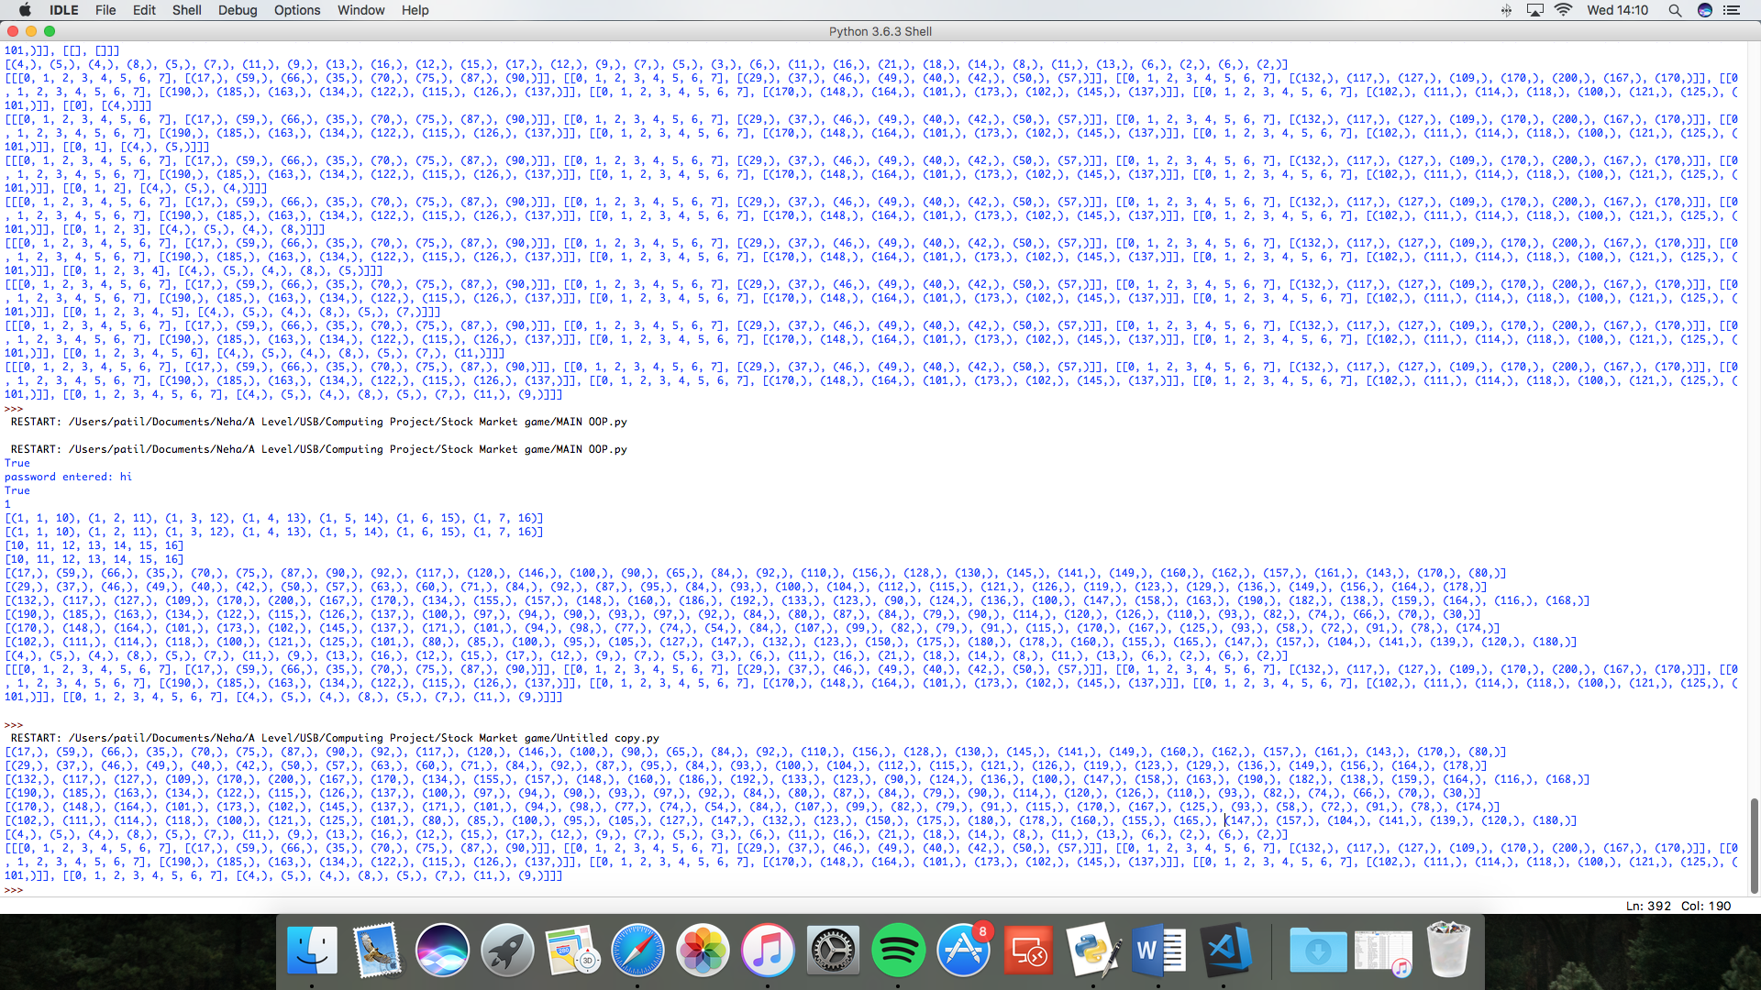

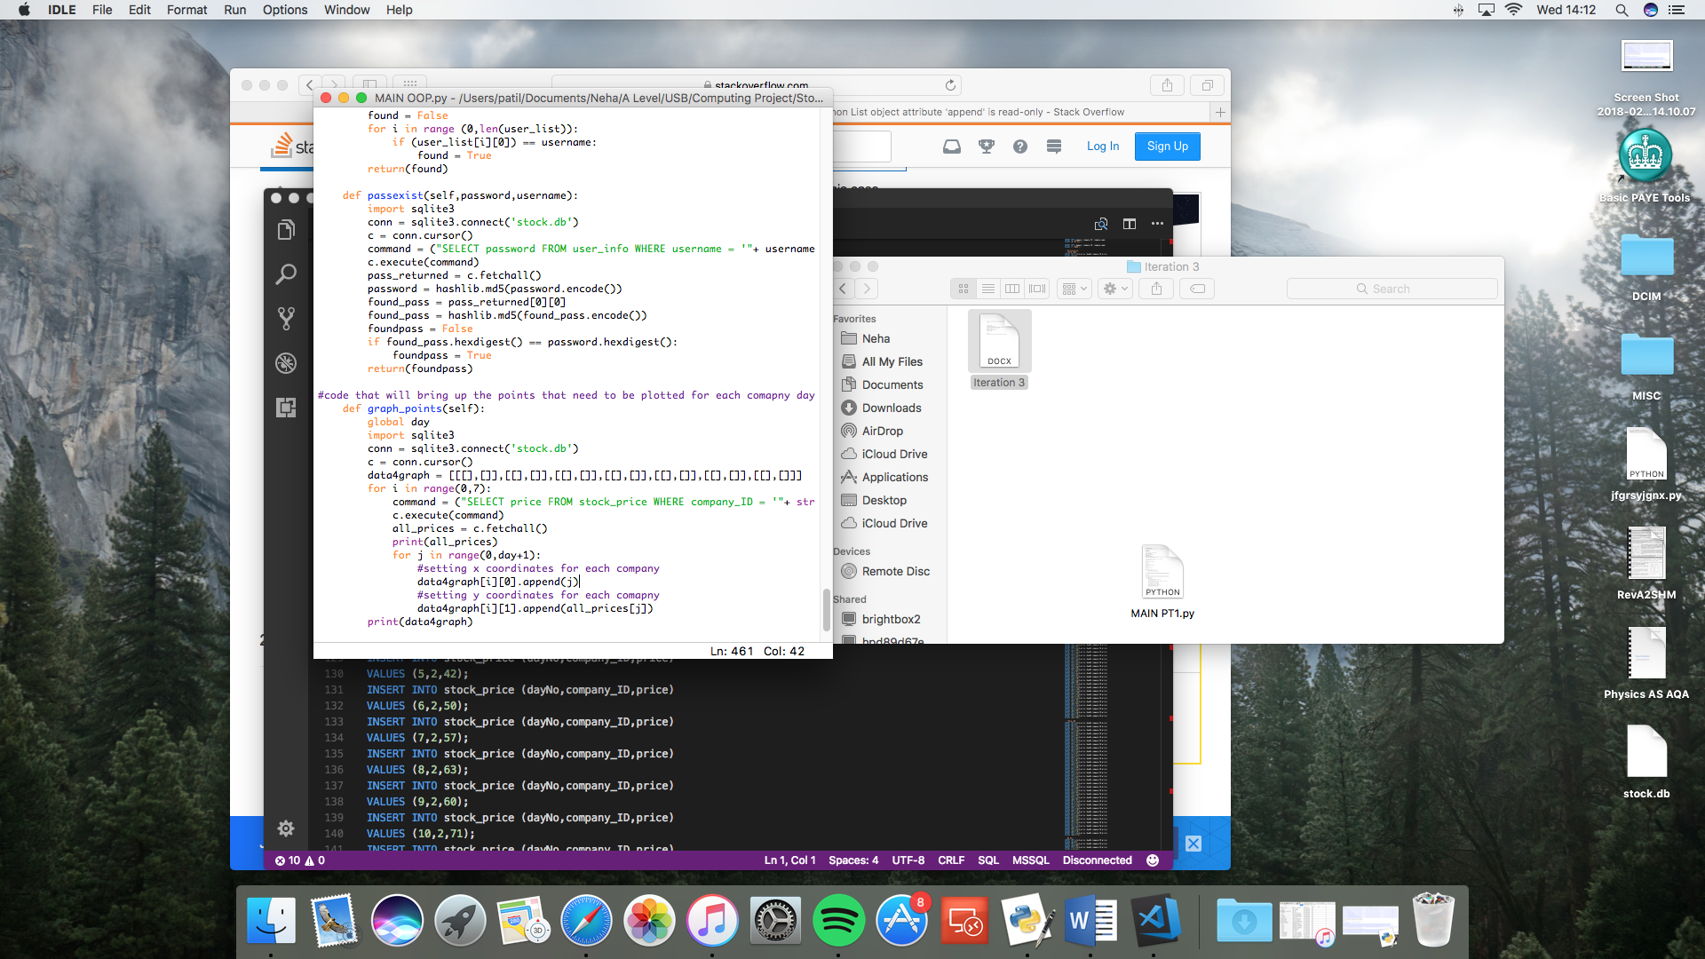

main pt 2 :

made bank show money in db and made bank update whne shares are bought and sold want to make bank show the money lost or gained

Erros & goal for iteration 4 : strengthen my controller

make the graph part of the mmain gui not another screen

legend covers up part of the graph

if graph apprears hints doents work and lg in pop up doesn’t go away

add more validation checks to the plog in

frames don’t fit properly

haven’t fixed next button yet

Need a gui redesign

Gonna have a textbox for notes

And have the percentage inc or decrease of companies in the assets frame as it is too long and there are not enough companies to buy and sell

**Pt1:**

**GUI:** added a buy & wrote a function for it

Asset dispay is updated – has to clear and reset the display as a way to update it

Made the frequency of images dependant on the level

**Main :** function that takes 3d array of assets and strips it to as imple list that can be easily updatded when things aree bought and sold

Selling assets queries for the cost of the assets add it to the money vaiable and then decrements the correct item in the assets list(‘no_owned), assets display is refreshed

One for buy as well

No_owned has got rid of a lot of global vairibales

**DB**:

Started writing the query to set the global variables

GUI and main now also have contractures to further strengthen my oop structure

Found a useless function called difficulty

Log in details validation

and then global variables set up

**LOGIN CLASS**: log in now part of the main program and who logs in infuences the variables

**Pt2:**

**GUI**: Bank does lots – updates with the assets frame when stuff is bought

Functions for bank set up and bank update

Bank initalieses amount depending on user with help from db class

First attemps at adding a graph A noticeable change that ahs also been made is the removal of the canvas from the graph frame of the GUI, this is

**Main**: now assets received from the db is only a 2d array that needs to be turned into a 1d array